The piston feeder GEBAR type GPT-1000
version without the pre-chamber of the mixer

Intended use:
The piston feeder GEBAR type GPT-1000 is destined to mix mineral and/or gypsum-mineral binders (including granulated binders) with liquids. The feeder is able to pump those binders on high distances constantly or periodically and is capable of gunning in underground excavations classified as levels a and b of methane explosion hazard and levels A or B of coal dust explosion hazard.

The feeder is made of following components:  - Supporting frame  - Sucking chamber  - Pumping system  - Drive | 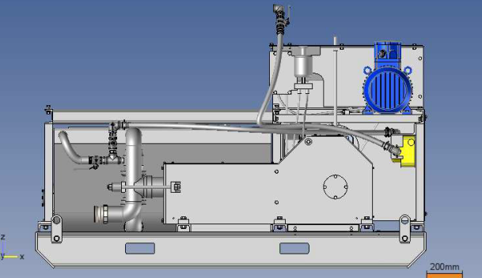
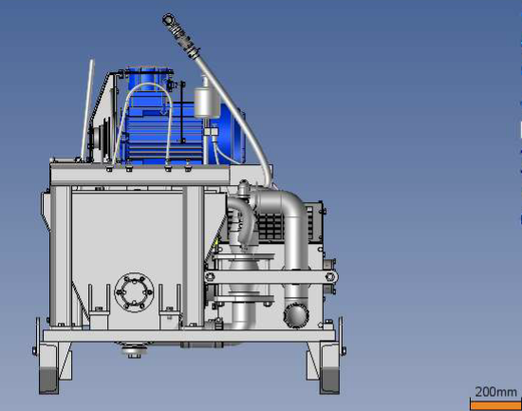 | 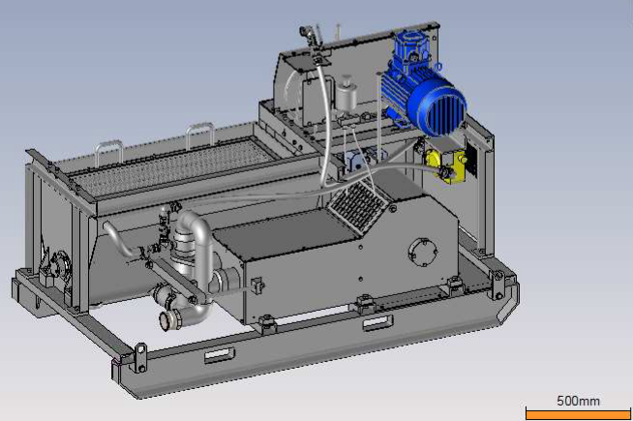

Description:
All elements are placed on the frame that allows transport of the device in the underground excavation grounds. Suction chamber allows the aggregation of the suspension mixture. Mixture from the suction chamber is moved into the pumping tube through the pumping system, which is two-cylinder piston pump with mechanical differential, suction and pressure valve system and safety valve. The change in the pumping efficiency is obtained by changing the gear in belt transmission. Drive unit consists of electric, pneumatic or hydraulic engine, and gear and belt transmission system.

Technical specification:
Pumping pressure | 4 MPa
Diameter of the pressure hose | 52 mm
Efficiency | 1,8 ÷ 5,5 m³/h
Range of horizontal pumping | ~ 800 m
Range of vertical pumping | ~ 150 m
Tank volume | ~ 240 l
Volume of the sucking pump | ~ 760 mm
Maximal granulation | 8 mm
Electric engine power | 7,5 kW
Dimensions (length. × width. × height) | ~ 2.150 × 1.150 × 1.320 mm
Mass | ~ 1.000 kg

